**1) Control Structures**

**Scenario 1:** Apply 1% Discount for Customers Above 60

BEGIN

  FOR cust_rec IN (

    SELECT l.LoanID, l.InterestRate, c.Name, c.DOB

    FROM Loans l

    JOIN Customers c ON l.CustomerID = c.CustomerID

  ) LOOP

    IF MONTHS_BETWEEN(SYSDATE, cust_rec.DOB) / 12 > 60 THEN

      UPDATE Loans

      SET InterestRate = InterestRate - 1

      WHERE LoanID = cust_rec.LoanID;

      DBMS_OUTPUT.PUT_LINE('Discount applied for customer: ' || cust_rec.Name);

    ELSE

      DBMS_OUTPUT.PUT_LINE('No discount: ' || cust_rec.Name || ' is not over 60.');

    END IF;

  END LOOP;

END;

**Output:** 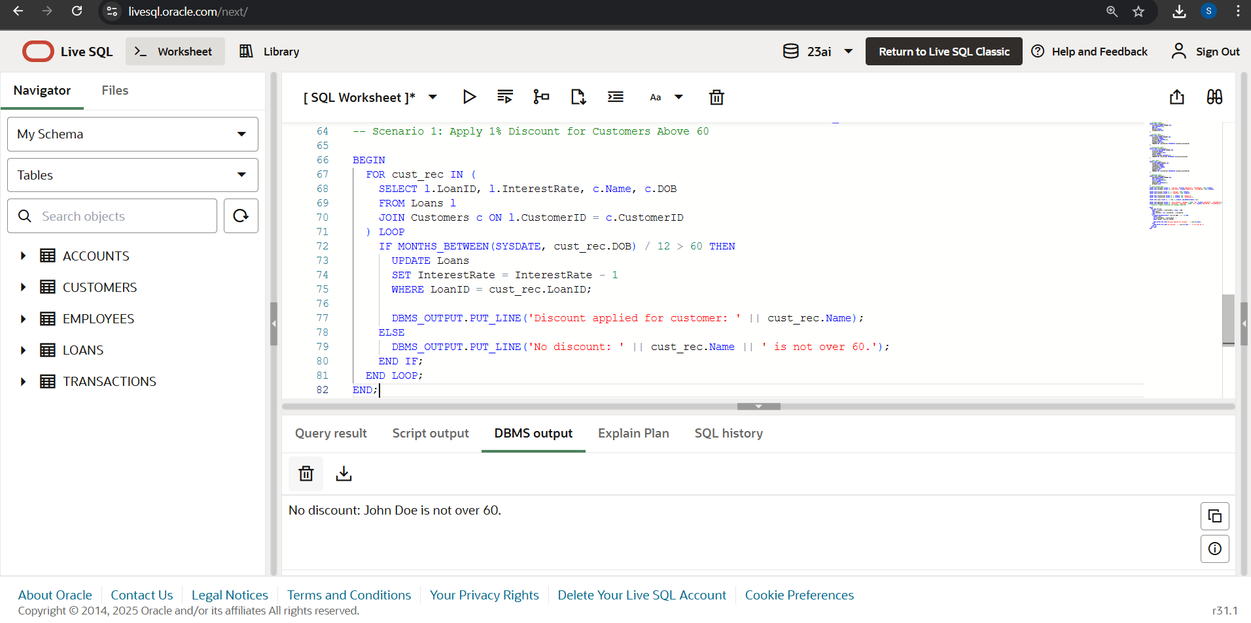

**Scenario 2:** Set IsVIP = TRUE for Customers with Balance > $10,000

ALTER TABLE Customers ADD IsVIP VARCHAR2(5);

BEGIN

FOR cust IN (SELECT CustomerID, Name, Balance FROM Customers) LOOP

IF cust.Balance > 10000 THEN

UPDATE Customers

SET IsVIP = 'TRUE'

WHERE CustomerID = cust.CustomerID;

DBMS_OUTPUT.PUT_LINE(cust.Name || ' is marked as VIP.');

ELSE

UPDATE Customers

SET IsVIP = 'FALSE'

WHERE CustomerID = cust.CustomerID;

DBMS_OUTPUT.PUT_LINE(cust.Name || ' is not VIP (balance too low).');

END IF;

END LOOP;

END;

**Output:**

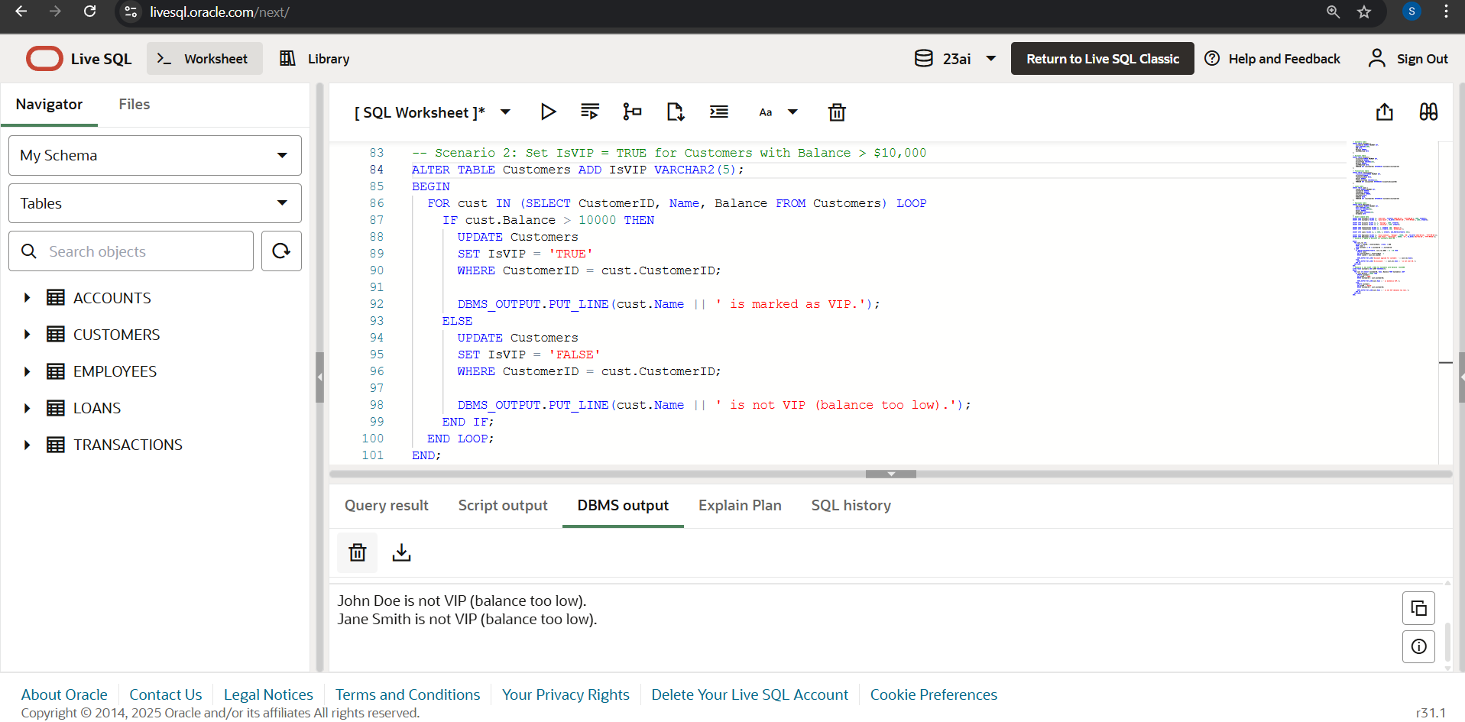

**Scenario 3:** Reminders for Loans Due in Next 30 Days

BEGIN

DECLARE

found BOOLEAN := FALSE;

BEGIN

FOR loan_rec IN (

SELECT l.LoanID, l.EndDate, c.Name

FROM Loans l

JOIN Customers c ON l.CustomerID = c.CustomerID

WHERE l.EndDate BETWEEN SYSDATE AND SYSDATE + 30

) LOOP

found := TRUE;

DBMS_OUTPUT.PUT_LINE('Reminder: Loan ID ' || loan_rec.LoanID || ' for ' || loan_rec.Name || ' is due on ' || TO_CHAR(loan_rec.EndDate, 'YYYY-MM-DD'));

END LOOP;

IF NOT found THEN

DBMS_OUTPUT.PUT_LINE('No loans due in the next 30 days.');

END IF;

END;

END;

**Output:**

